**VANN VNRG  
Migration Consultants**

Service

Home

About

Contact



**Planning to go oversea?**

**Unknowing what to do?**

*It is our priority to help you*

Book Now

Story

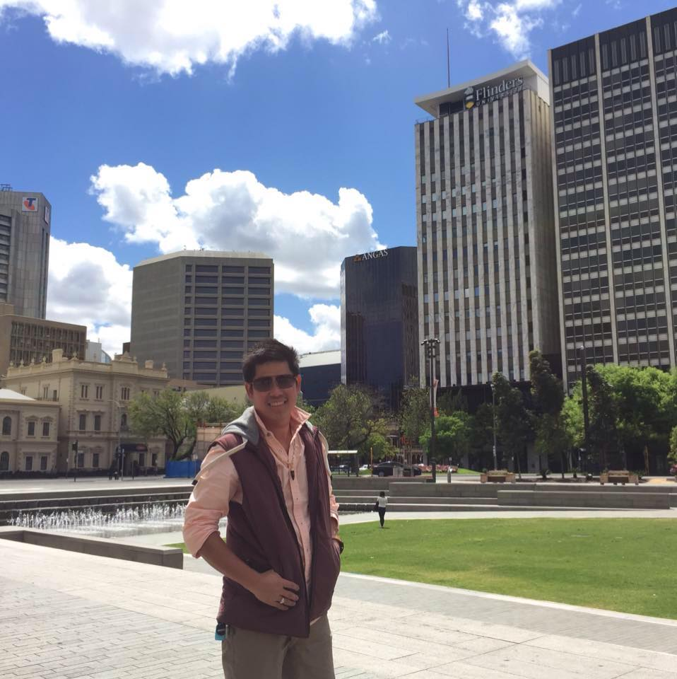

My story:

I was graduated in the University of Cambodia. I was planning to continue my study in Australia however, I didn't have much idea what to do?

After I met with Mr Vann, he has provided information about my study. I have used his service and I am extremely satisfied because he has organized and support me with every procedure to get my student Visa.

Now I am in Adelaide and I am still in touch with him for further assistance.

BOOK NOW

Services

Canada

USA

Australia

New Zealand

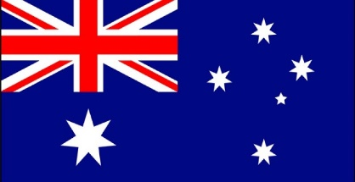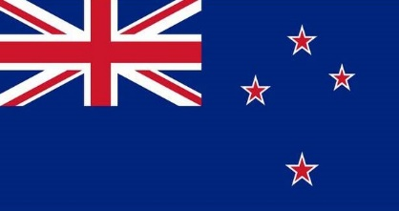

Are you looking for the right Visa?

Vann is expertise in the following visa:

##### Employment

##### Business

##### Family

##### Study

Read more

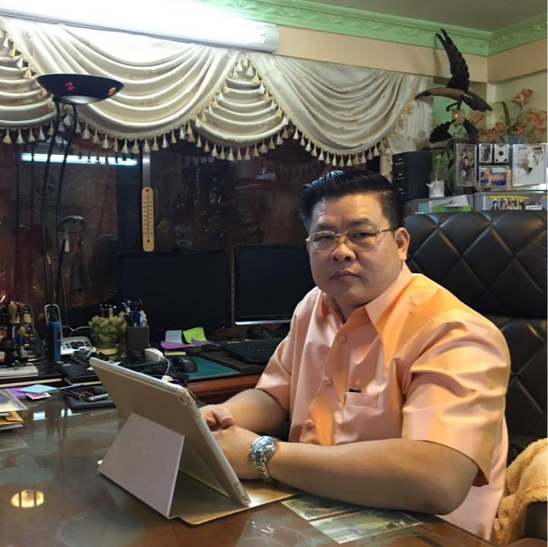

Hi and welcome! I’m Vann. I am one of the leading Cambodia migration consultancy. I’m working closely with countries such as Australia, New Zealand, USA and Canada. I am providing guild-lines and advice to every situation according to individual circumstances. As registered migration agent I have dept-knowledge of international laws, regulation and policy. Applying Visa to international countries are extremely sophisticated, do it right at the beginning will save your money and time. I have established my business since 2000. 17 years of experience you will confident in my work. I will simplify processes into simple steps with precise information for you to follows. While you just sit back and relax, I will work with the immigration department.

About me

HOW I CAN   
 HELP YOU

NAME

MESSAGE

Successful Applicants Rate

99 %

SUBJECT

EMAIL

SEND

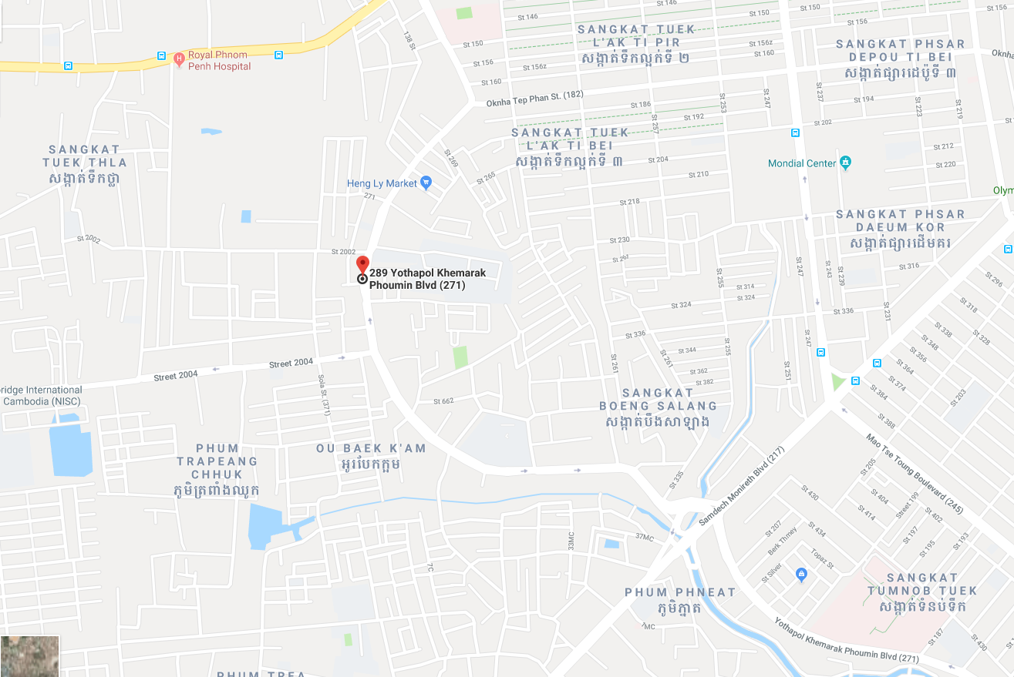

Contact

## VORNG VANN

**Visit Address:**

#35Eo, Street 271, Sen Sok

PO BOX: 573, Phnom Pench, Cambodia

**Call:**

Tel: (855) 012 507171 / 070 507171

Contact: [visas.centre@gmail.com](mailto:visas.centre@gmail.com)

Website: [vorngsovann.com](mailto:info@mysite.com).kh